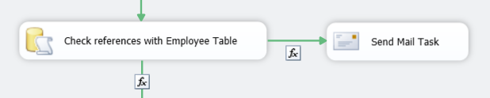

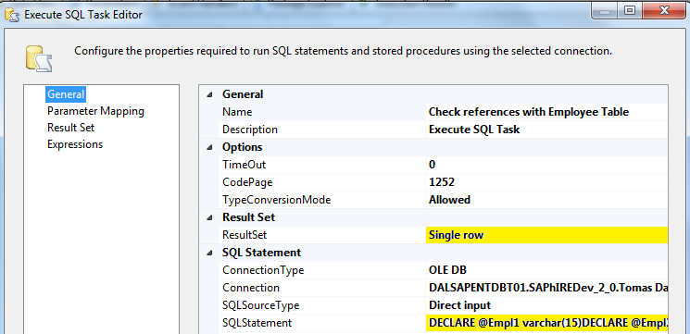

DECLARE @Empl1 varchar(15)

DECLARE @Empl2 varchar(1000)

DECLARE cur2 CURSOR FAST_FORWARD FOR

SELECT Event_user_id

FROM Atrack_Event_Ticket_DataStaging

WHERE Event_user_id is not null

AND Event_user_id not in

( SELECT GlobalEmployeeNumber FROM Employee )

GROUP BY Event_User_Id

SELECT @Empl2 = ''

OPEN cur2

FETCH NEXT FROM cur2 INTO @Empl1

WHILE @@FETCH_STATUS = 0

BEGIN

SELECT @Empl2 = @Empl2 + ', ' + @Empl1

FETCH NEXT FROM cur2 INTO @Empl1

END

CLOSE cur2

DEALLOCATE cur2

IF @Empl2 <> ''

BEGIN

SELECT @Empl2 = 'The following values do not have reference with Employee table : ' + @Empl2

END

SELECT @Empl2 AS LISTADO

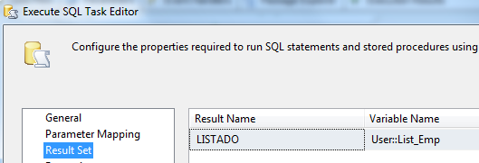

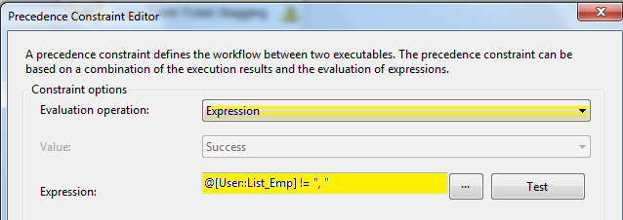

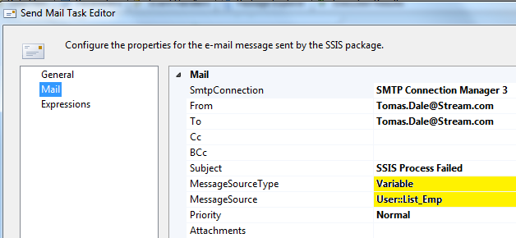

El SmtpConnection debe ser mailedc01